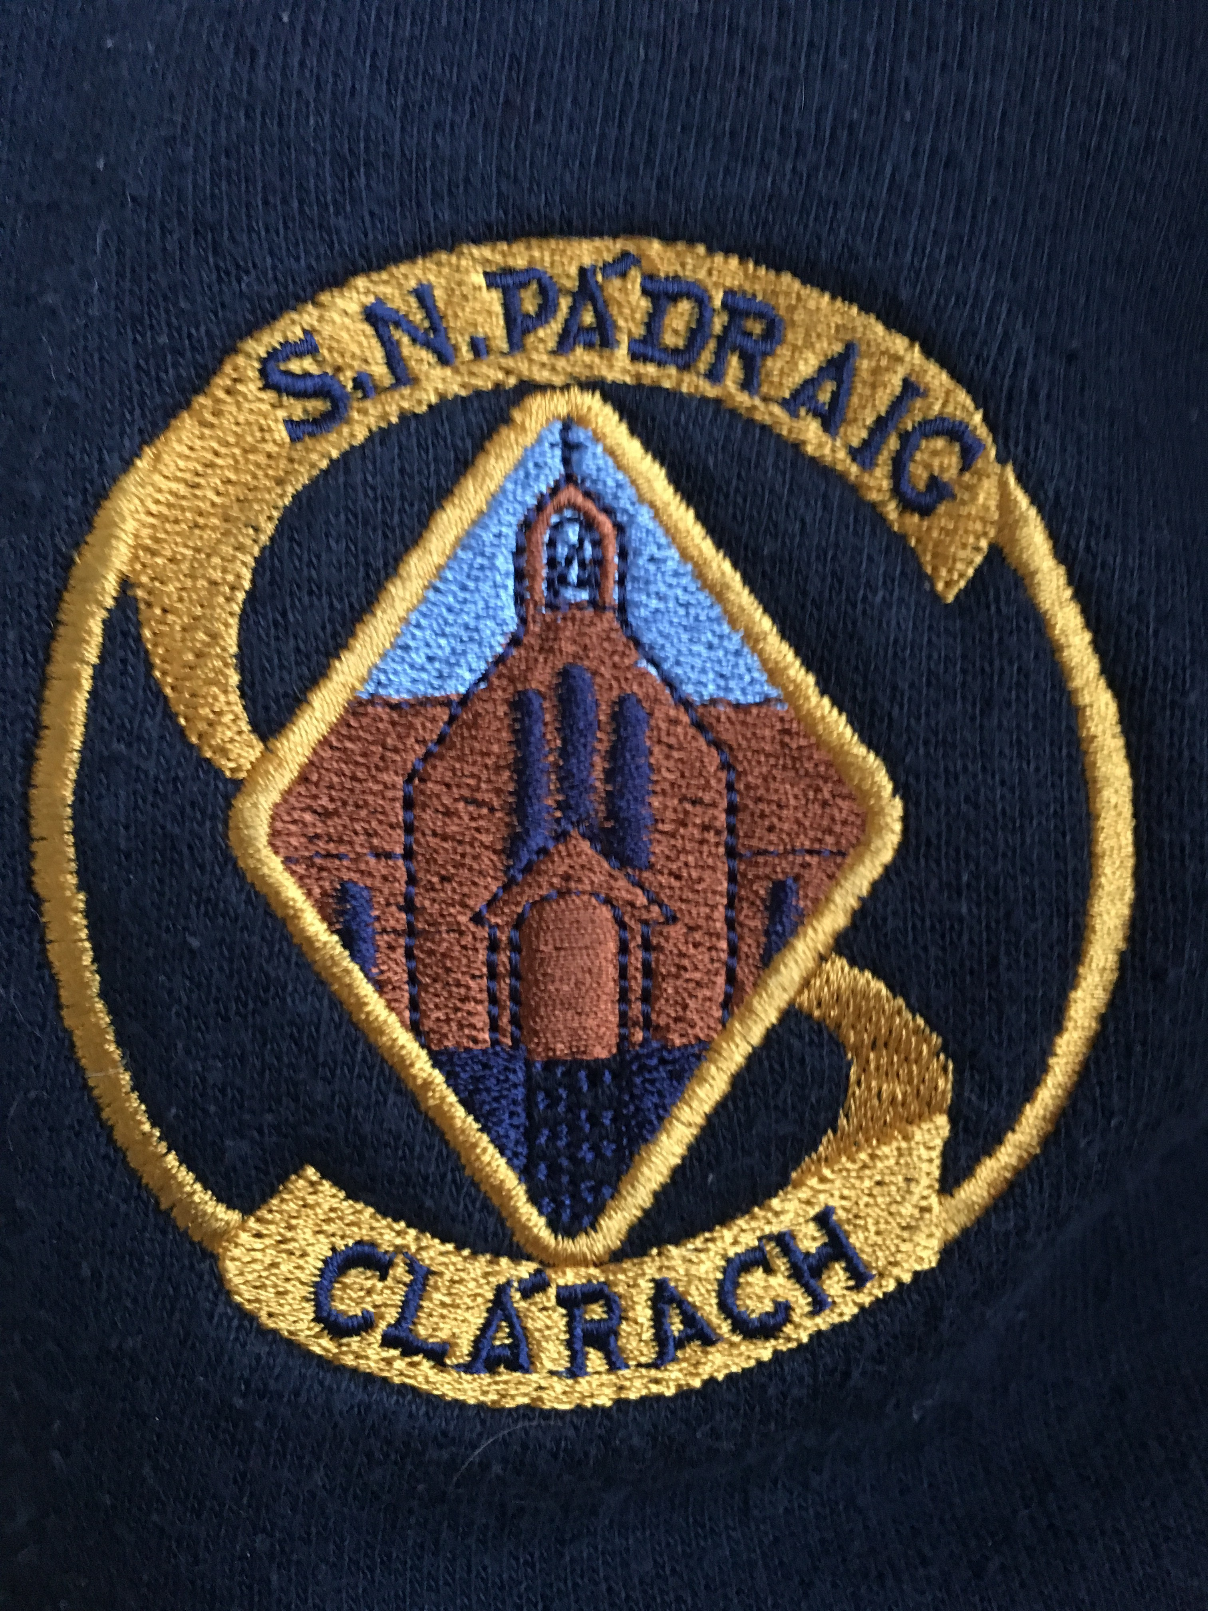
Dear Parent/ Guardian,
We are delighted to inform you that our school is now moving on from traditional spelling books. Spelling books have been used for over 150 years in the education system. These traditional books are generic and do not provide differentiated learning for your child. They do not consider your child’s individual spelling ability. They simply set a very general standard, based on whatever class your child is in. Traditional spelling books endorse a “one size fits all” approach.
The revolutionary Spellings for Me interactive programme, is completely the opposite. Everything is individualised for your child- essentially a tailor-made spelling programme. Your child’s spellings will be solely based on the words that they do not know how to spell, based at their own level. No two children will have the same spellings, as no two children are the same.
The teaching and learning of spellings have evolved, but until now, there has been no resource to facilitate this. We are very excited to embrace more efficient methods of teaching and learning spellings that Spellings for Me will bring. We are confident that your child will be too!
Traditional methods like “writing spellings out 5 times” and Friday tests are archaic and proven to be completely inefficient by studies. Spellings for Me incorporates meaningful, enjoyable activities for your child, that are proven to improve children’s spellings. Spellings for Me embraces continuous learning and continuous assessment throughout your child’s whole spelling journey through primary school.
If you would like to see their progress, you can log into their own profile. Here you will see:
- What level your child is on by seeing how many yellow ticks he/she has.
- How many words he/she already knew how to spell by looking at the ‘Certificates’ section.
- How many words they have ‘mastered’. Mastered words are words that the child has spelled wrong but has since learned them and spelled them correctly on the online test. You can view how many Mastered Words he/she has in the ‘Certificates’ section.
Children can be retested again and again on these words to make sure they really know them. Your child will earn certificates, which are also available on their profile. This is a great way to celebrate their achievements at their own level.
“Torbe 1993 states that ‘spelling instruction should always acknowledge the uniqueness of the learner and so an individualised approach is always best.’ This supports Anderson & Lapp (1988) who argued that an individualised approach to spelling is most successful. In Ireland, the traditional approach to learning spellings is usually whole class teaching (a one size fits all approach). It is not best practice to have every child in the class learning the same list of words.” (Culligan 1997)
If you want to learn more about Spellings for Me, you can visit their website www.spellingsforme.ie. Here there are an abundance of videos and information explaining the programme. They also have a downloadable ‘Parent Guide’ to help you support your child in spellings. At long last, we have a totally meaningful way of teaching spellings. Spellings for Me will revolutionise the way children learn spellings and what's more, they will have fun!
Instructions on how to log in
Option 1: | 1. Go to www.spellingsforme.ie  2. Click 'Login'  3. Change your URL by clicking ' change'  4. Type in your school personal URL (ours is enter school personal URL here)  5. Click 'save'  6. Enter your username and password
Option 2: | Our personal school link to Spellings for Me is:  https://yourschoolpersonalURLhere.spellingsforme.ie/account/login  With this link you only need to enter your child’s username and password.  *You may wish to put this link on your school website.

